Exercise 8: Custom middleware

Objective
In this exercise, you'll learn how to write middleware in an Express application that is a crucial skill for developing efficient, scalable, and maintainable web applications. Middleware functions can perform a variety of tasks like logging, parsing, authentication, and more. They have access to the request (req), the response (res), and the next function in the application’s request-response cycle. The next function is a function in the Express router which, when invoked, executes the middleware succeeding the current middleware.

Exercises

Exercise 1: create a middleware function that checks the validation of the request body for the articles endpoint
- From the node-express app in exercise 6 part 1, create validateArticle function as middleware to check the validation of the request body for the articles endpoint
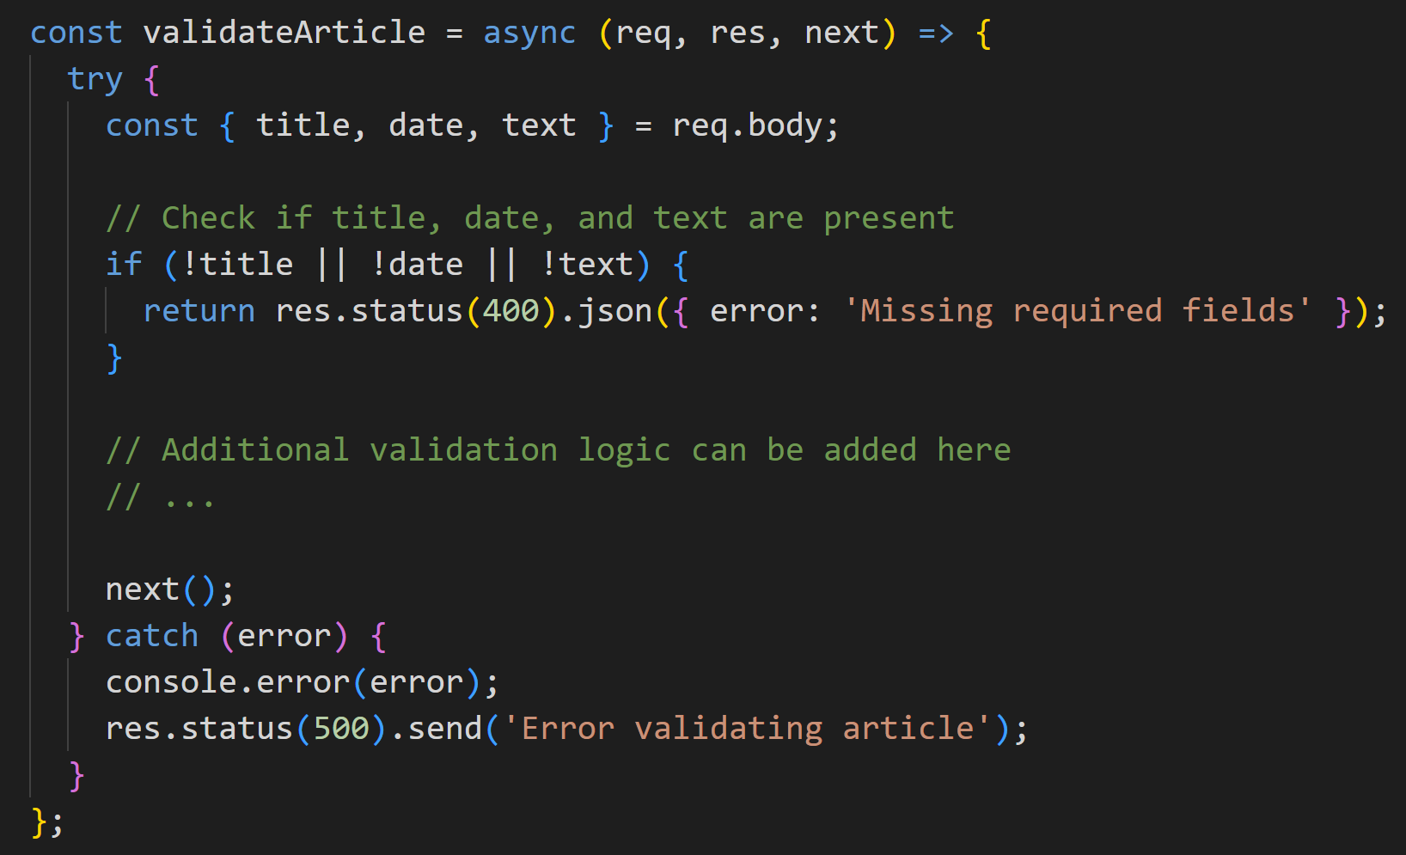

- Using validateArticle middleware as code below

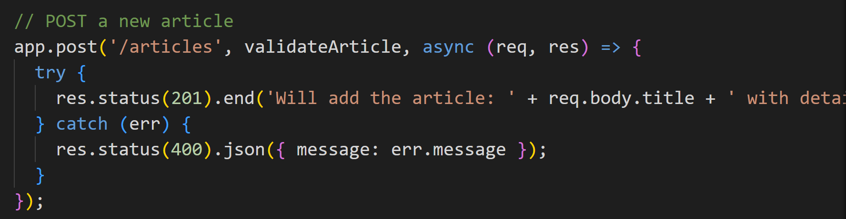

- Test with Postman
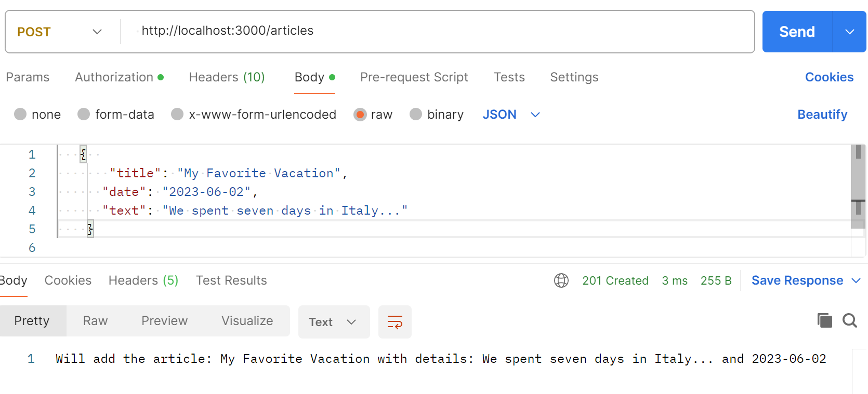

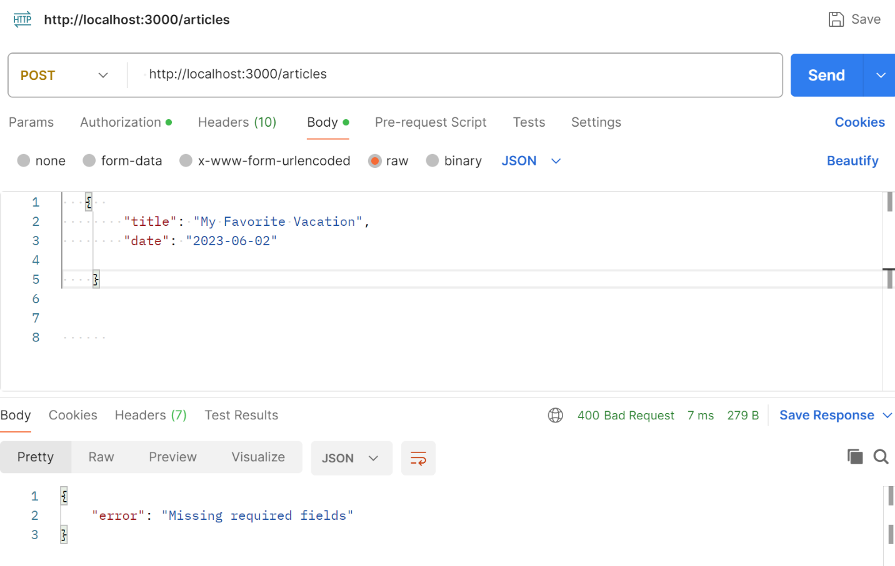

Exercise 2: create a middleware function that validate the format of the date field.

Exercise 3: create a middleware function that ensure a text field meets certain length requirements

Exercise 5: Separating middleware into different files can enhance the modularity and maintainability of your Express.js application, especially as it grows. This approach allows you to organize your code logically, making it easier to understand, debug, and test.

Conclusion
This exercise aims to deepen your understanding of how to build a middleware with Express framework. Middleware functions are powerful tools in Express, allowing you to handle requests efficiently and perform various operations like logging, authentication, and error handling. By writing custom middleware, you can significantly enhance your application's functionality and maintainability. Experiment with different types of middleware to see how they can solve common problems in your applications.

